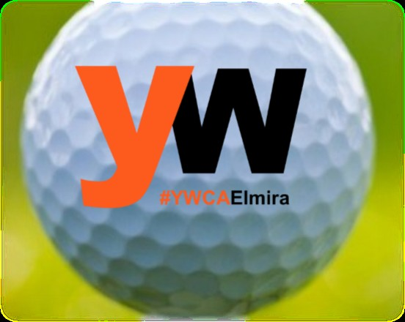
YWCA
Charity Golf Tournament

September 17, 2023

Shotgun start @ 10:00 AM Tomasso’s Golf Course

We will be playing Captain and Crew format! Your entrance fee ($380 per team of 4) includes green fees, cart, lunch at the turn and dinner at the banquet. The prize banquet will take place immediately after golf at Tomasso’s.
Sponsor a Hole:
$150
Team Name: PLAYER 1 PLAYER 2 PLAYER 3 PLAYER 4

Mail completed registration to:
YWCA Elmira & the Twin Tiers Attn: A’Don Allen
211 Lake Street, Elmira, NY 14901 Email:- adona@ywcaelmira.org Phone: 607-733-5575 x227

You can also register on our website: ywcaelmira.org/online-store
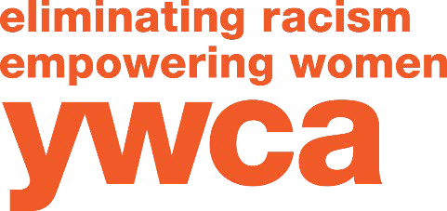
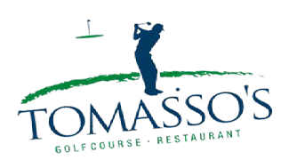

SPONSORSHIP OPPORTUNITIES:

Company Name: _ Website: _ Address: _ Contact Name: Phone: Email: _ Please complete above information for team play and/or sponsorship
Eagle Level Sponsorship- $700
- Marketed as top sponsor with logo on all promotional material
- A table at the event to distribute marketing materials
- Business sign at registration and lunch
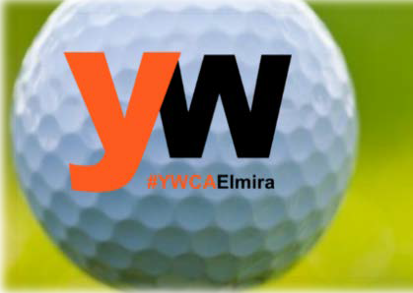
- Logo added to the YWCA website

Birdie Level Sponsorship- $500
- Logo added to YWCA website
- Logo on all promotional materials

Captain and Crew Team (4) - $380
We also request donations for team Welcome bags and raffle prizes

Send checks to:
YWCA Elmira 211 Lake Street
Elmira, NY 14901

YWCA Elmira and Twin Tiers is dedicated to eliminating racism, empowering women and promoting peace, justice, freedom, and dignity for all.

