SPONSORSHIP OPPORTUNITIES:

Company Name: _ Website: _ Address: _ Contact Name: Phone: Email: _ Please complete above information for team play and/or sponsorship
Eagle Level Sponsorship- $700
- Marketed as top sponsor with logo on all promotional material
- A table at the event to distribute marketing materials
- Business sign at registration and lunch
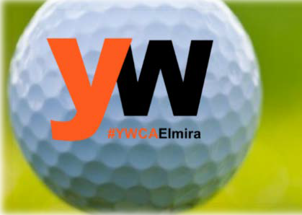
- Logo added to the YWCA website

Birdie Level Sponsorship- $500
- Logo added to YWCA website
- Logo on all promotional materials

Captain and Crew Team (4) - $380
We also request donations for team Welcome bags and raffle prizes

Hole Sponsorship- $150

Send checks to:
YWCA Elmira 211 Lake Street
Elmira, NY 14901

YWCA Elmira and Twin Tiers is dedicated to eliminating racism, empowering women and promoting peace, justice, freedom, and dignity for all.

